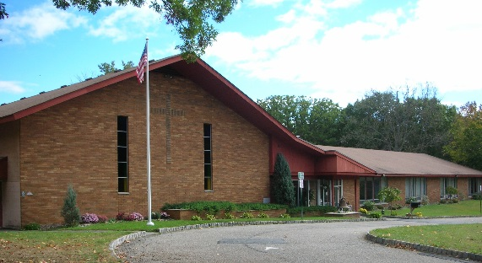
Holy Trinity Lutheran Church
508 Green Pond Road

Rockaway, NJ 07866

973-625-0110

htl.church@gmail.com

FALL FESTIVAL & CARSHOW
SEPTEMBER 28th 2019

BUSINESS OR ORGANIZATION
DONATION LEVEL 1 (MAIN EVENT SPONSOR)
- ALL SOCIAL MEDIA AND BANNER BENEFITS OF DONATION LEVEL 1 AND LEVEL 2 (36”x48” SIZE )
- BUSINESS NAME INCLUDED IN NEWSPAPER AD FOR THE EVENT AND SOCIAL MEDIA ADS FOR THE EVENT
- 1 EXTRA LARGE SPONSOR BANNER POSTED IN MOST PROMINENT LOCATION (3’x8’ SIZE )
- MUSIC STAGE MENTION EVERY HOUR FOR THE EVENT
$1000
BUSINESS OR ORGANIZATION
DONATION LEVEL 2
- ALL SOCIAL MEDIA BENEFITS OF DONATION LEVEL 1
- (3) BANNERS WITH YOUR BUSINESS POSTED AT THE EVENT IN MOST PROMINENT LOCATIONS ( 36”x48” SIZE )
- ALL BANNERS DOUBLE SIZED OF DONATION LEVEL 1
- MUSIC STAGE MENTION AT END OF THE EVENT
$500
BUSINESS OR ORGANIZATION
DONATION LEVEL 3
- A BANNER WITH YOUR BUSINESS POSTED AT THE EVENT ( 18”x24” SIZE )
- BANNER WITH ALL OUR SPONSORS POSTED IN THE CHURCH FOR THE REMAINDER OF THE YEAR THROUGH HOLIDAY SEASON
- THANK YOU TO OUR SPONSORS NAMING ALL ON OUR WEBSITE AND FACEBOOK PAGE
- WEEKLY HANDOUT AT THE CHURCH WILL INCLUDE YOUR BUSINESS AS A SPONSOR
- PAID POST TO BE SHARED WITH ALL SOCIAL MEDIA AND CHURCH MEMBERS AND ENCOURAGED TO BE SHARED AMONG THEIR FAMILY AND FRIENDS
$250
BUSINESS NAME: ________________________________
ADDRESS: ______________________________________
______________________________________________
______________________________________________
CONTACT PERSON: ________________________PHONE: ___________________
EMAIL ADDRESS: ____________________________________________________
DONATION LEVEL: _________ ADDITIONAL DONATIONS: ____________________
COMMENTS:__________________________________________________________________________________________________________________________________________________________________________________________________________________________________________________________________________________________________________________________________________________________________________________________________________________________________________________________________________
MAKE CHECKS PAYABLE TO HTLC

