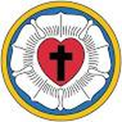
500th Anniversary of the Reformation Celebration at HTLC
Martin Luther coming to Holy Trinity Lutheran Church
Sunday, October 29, 11:00 a.m.
508 Greenpond Road, Rockaway, NJ

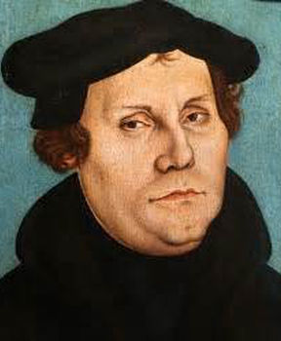
Dr. Luther will be interviewed by our Ace Reporter: Ruth Ann Greiner
The event will feature Music by the Church Choir,
Church Instrumental Musicians, and our Sunday School Children

